**Stephan**

**Abstract**

A critical step in the fight against COVID-19 is effective screening of infected patients, with one of the key screening approaches being radiology examination using chest radiography. It was found in early studies that patients present abnormalities in chest radiography images that are characteristic of those infected with COVID-19. Motivated by this and inspired by the open-source efforts of the research community, in this study we introduce COVID-Net, a deep convolutional neural network design tailored for the detection of COVID-19 cases from chest X-ray (CXR) images that is open source and available to the public. To the best of the authors’ knowledge, COVID-Net is one of the first open-source network designs for COVID-19 detection from CXR images at the time of initial release.

**Model**

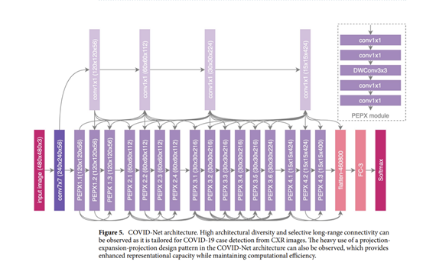

Lightweight design pattern. It can be observed that the COVID-Net network architecture makes heavy use of a lightweight residual projection-expansion-projection-extension (PEPX) design pattern, which consists of: • First-stage projection 1×1 convolution for projecting input features to a lower dimension,

• Expansion: 1×1 convolution for expanding features to a higher dimension that is different than that of the input features,

• Depth-wise representation efficient 3×3 depth-wise convolutions for learning spatial characteristics to minimize computational complexity while preserving representational capacity,

• Second-stage projection 1×1 convolution for projecting features back to a lower dimension, and

• Extension: 1×1 convolutions that finally extend channel dimensionality to a higher dimension to produce the final features.

**Performance**

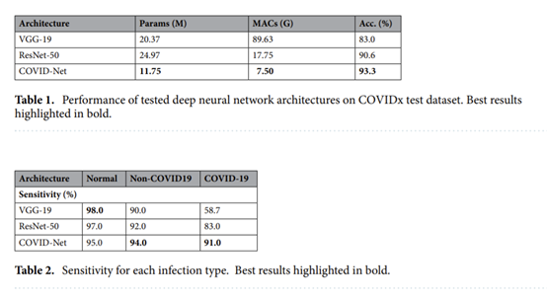

**JT**

**Abstract**

**Model**

  we fine-tune the last layer of the pre-trained version of these models on ImageNet. In this way, the model can be trained with less labeled samples from each class.

**Performance**

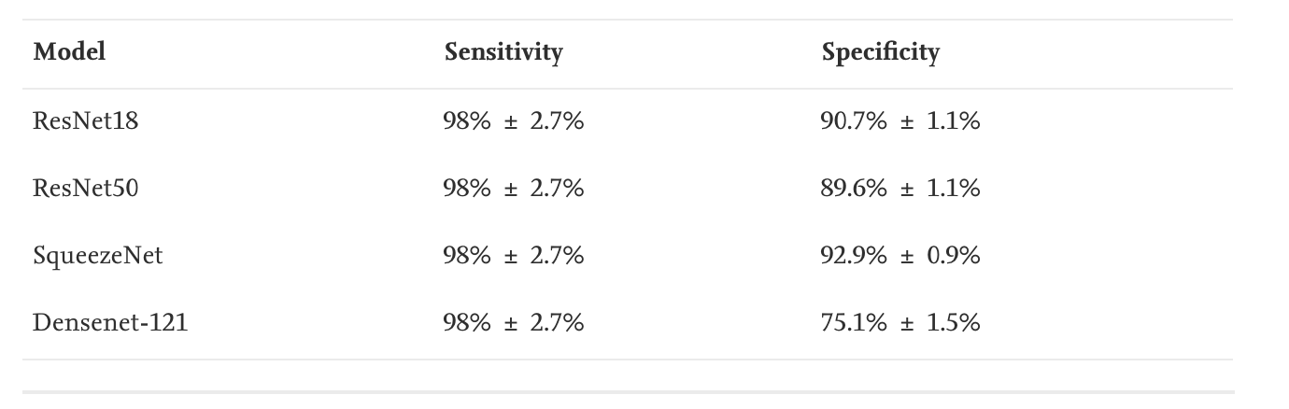

**Pranav**

**Abstract**

* Reliable way to detect COVID-19 cases is using chest x-ray images, where signals of the infection are located in lung areas.
* The two-classes-based version is used to classify chest x-ray images into COVID-19 and non-COVID-19.
* Data augmentation is also applied on the original training images to enhance the regularization of the model.
* The ResNet-101 architecture is adopted as the main network with more than 44 millions parameters.
* The sigmoid was used as an activation function, with the binary cross-entropy loss function.
* The whole net is trained using the large size of 1500 × 1500 x-ray images.
* The heatmap under the region of interest of segmented lung is constructed to visualize and emphasize signals of COVID-19 in each input x-ray image.
* The developed solution can also generate the heatmap with a confidence score of being COVID-19, to emphasize the result on each test image. The heatmap is visualized on only lung regions segmented using U-Net.
* Lungs are segmented using the pretrained U-Net.
* The confidence score of being COVID-19 is also calculated for each classification result.
* The proposed solution achieves very promising sensitivity, specificity, and accuracy of 97%, 98%, and 98%, respectively.

**Model**

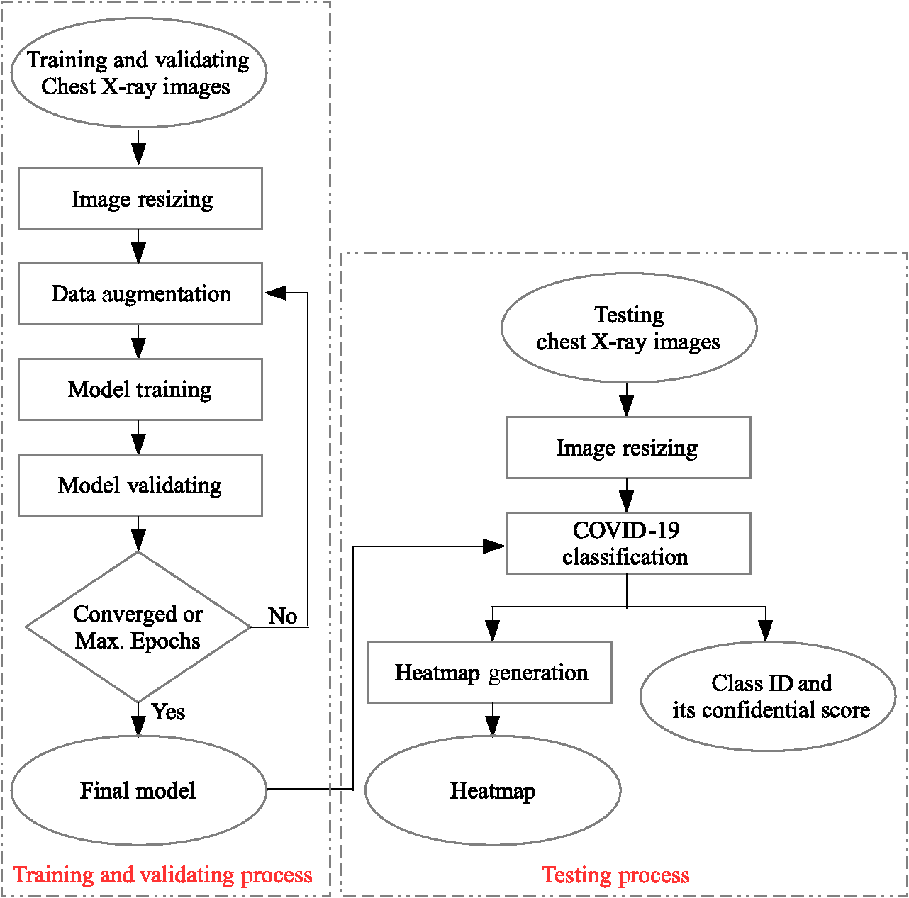

* The convolutional layers in ResNet-101 used in the proposed solution.
* The ResNet-101 is trained from scratch using the input images of the large size 1500×1500pixels.
* The top part (i.e., classification part) of ResNet-101 is replaced with the global average pooling, softmax, and output layers.
* Five types of data augmentations are added on the training dataset, including zoom, rotate, shear, flip, and shift.[25](https://www.spiedigitallibrary.org/journals/journal-of-medical-imaging/volume-8/issue-S1/014001/COVID-19-detection-and-heatmap-generation-in-chest-x-ray/10.1117/1.JMI.8.S1.014001.full#r25)
* In the testing phase, the trained model is applied on each resized chest x-ray image, to compute predicted class, its confidence score, and heatmap. The details are explained in the following sections.
* The convolutional layers in ResNet-101 used in the proposed solution.

|  |  |  |
| --- | --- | --- |
| **Layer name** | **Building block of (kernel size, filter)** | **Number of building blocks** |
| conv1 | [7×7,64] |  |

|  |  |
| --- | --- |
|  | 1 |
| conv2 | ⎡⎢⎣1×1,643×3,641×1,256⎤⎥⎦ |

|  |  |
| --- | --- |
|  | 3 |
| conv3 | ⎡⎢⎣1×1,1283×3,1281×1,512⎤⎥⎦ |

|  |  |
| --- | --- |
|  | 4 |
| conv4 | ⎡⎢⎣1×1,2563×3,2561×1,1024⎤⎥⎦ |

|  |  |
| --- | --- |
|  | 23 |
| conv5 | ⎡⎢⎣1×1,5123×3,5121×1,2048⎤⎥⎦ |

|  |  |
| --- | --- |
|  | 3 |

* 5 different data sets have been used.
* Sample final heatmaps with their confidence scores of the false-positive cases. The first two images are normal cases and the last image contains another abnormality.

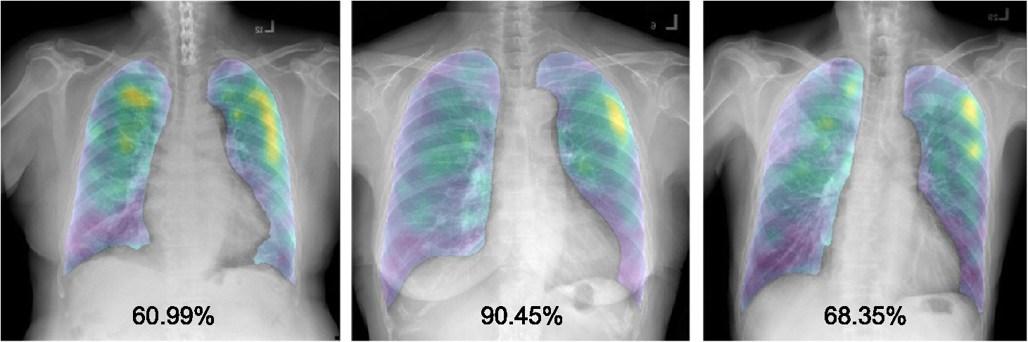

**Performance**

Experimental results of scenario 1.

|  |  |  |
| --- | --- | --- |
| **True labels** | **Predicted classes** | |
| **COVID-19 (class 1)** | **Non-COVID-19 (class 2)** |
| COVID-19 (class 1, D1) | 97% | 3% |
| Non-COVID-19 (class 2, D2) | 2% | 98% |
| Non-COVID-19 (class 2, D3+D4) | 85% | 15% |

* The model is further improved by adding sample chest x-ray images containing other remarks and diseases in the training and validating processes. This makes the model to learn differences between patterns of COVID-19 and patterns of other diseases.

**Edison**

**Abstract**

In order to alleviate overfitting of the model, multi-image augmentation is used for training the model using sharpening filters. This augmentation generates a number of representative images carrying discontinuity information.

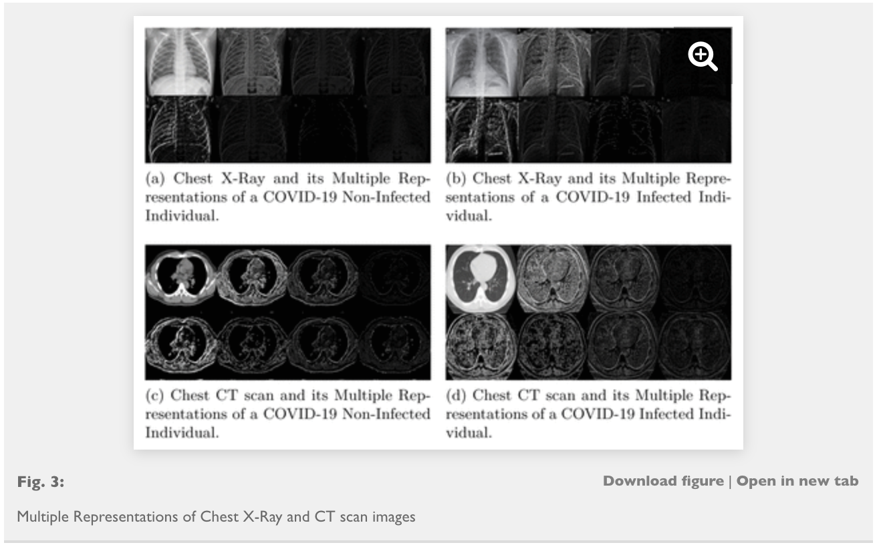

**Model**

 Multi-Image Augmented Deep Learning Model. First, the input image is converted into grayscale. Then, edge detection operators are applied. Finally, LeNet model is exploited.

**Performance**

Accuracy: 95.38%(CT) 98.97(X-ray)

Sensitivity: 94.78%(CT) 99.07%(X-ray)

Specificity: 95.98%(CT) 98.88%(X-ray)

The proposed augmented deep model outperforms ResNet-50 and VGG-16 as well as the existing models too.

**Hannah**

**Abstract**

**Model**

five keras-related deep learning models: ResNet50, InceptionResNetV2, Xception, transfer learning and pre-trained VGGNet16 is applied to formulate an classification–detection approaches of COVID-19.

Two benchmark methods SVM (Support Vector Machine), CNN (Conventional Neural Networks) are provided to compare with the classification–detection approaches based on the performance indicators, i.e., precision, recall, F1 scores, confusion matrix, classification accuracy and three types of AUC (Area Under Curve).

**Performance**

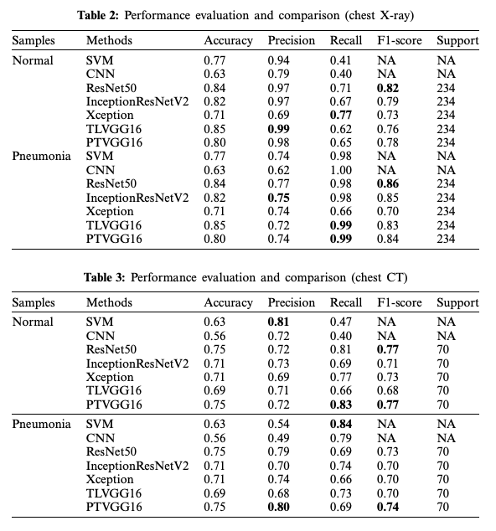

**Allen**

**Abstract**

Problem: CT and lab kits are expensive, ther is no effective treatment. Effiective diagonose is criticial . The paper aims to present the use of deep learning for the high-accuracy detection of COVID-19 using chest X-ray images.

**Model**

38 experiments were using convolutional neural networks(4 differnet structure of convNets )

10 exp with 5 machine learning models( svm, lr, nb, dt and knn)

and 14 under he state-of-the-art pre-trained networks for transfer learning(VGG 16,19, Inception V3, mobileNet ResNet 50,DenseNet 121)

**Performance**

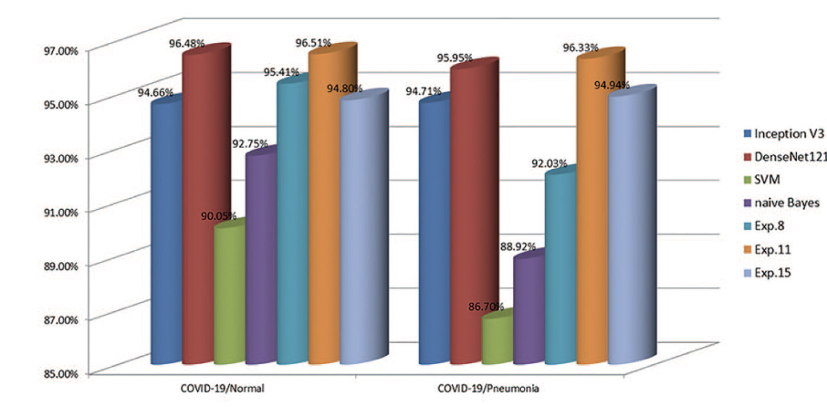

mean sensitivity of 93.84%,

mean specificity of 99.18%,

mean accuracy of 98.50%,

and mean auc of 96.51%

A convolutional neural network without pre-processing and with minimized layers is capable of detecting COVID-19 in a limited number of, and in imbalanced, chest X-ray images.

**To DO:**

1. **SVM/NB/KNN/LR/KNN/RF/Simple CNN/Simple Feedforward NN/RNN**
2. **More Complicated models (Transfer Learning)**
3. **Data augmentation: Sharpening/Rotating/Zoom/Flip/Shift**
4. **Heatmap**

**CovidNet Github: https://github.com/lindawangg/COVID-Net**